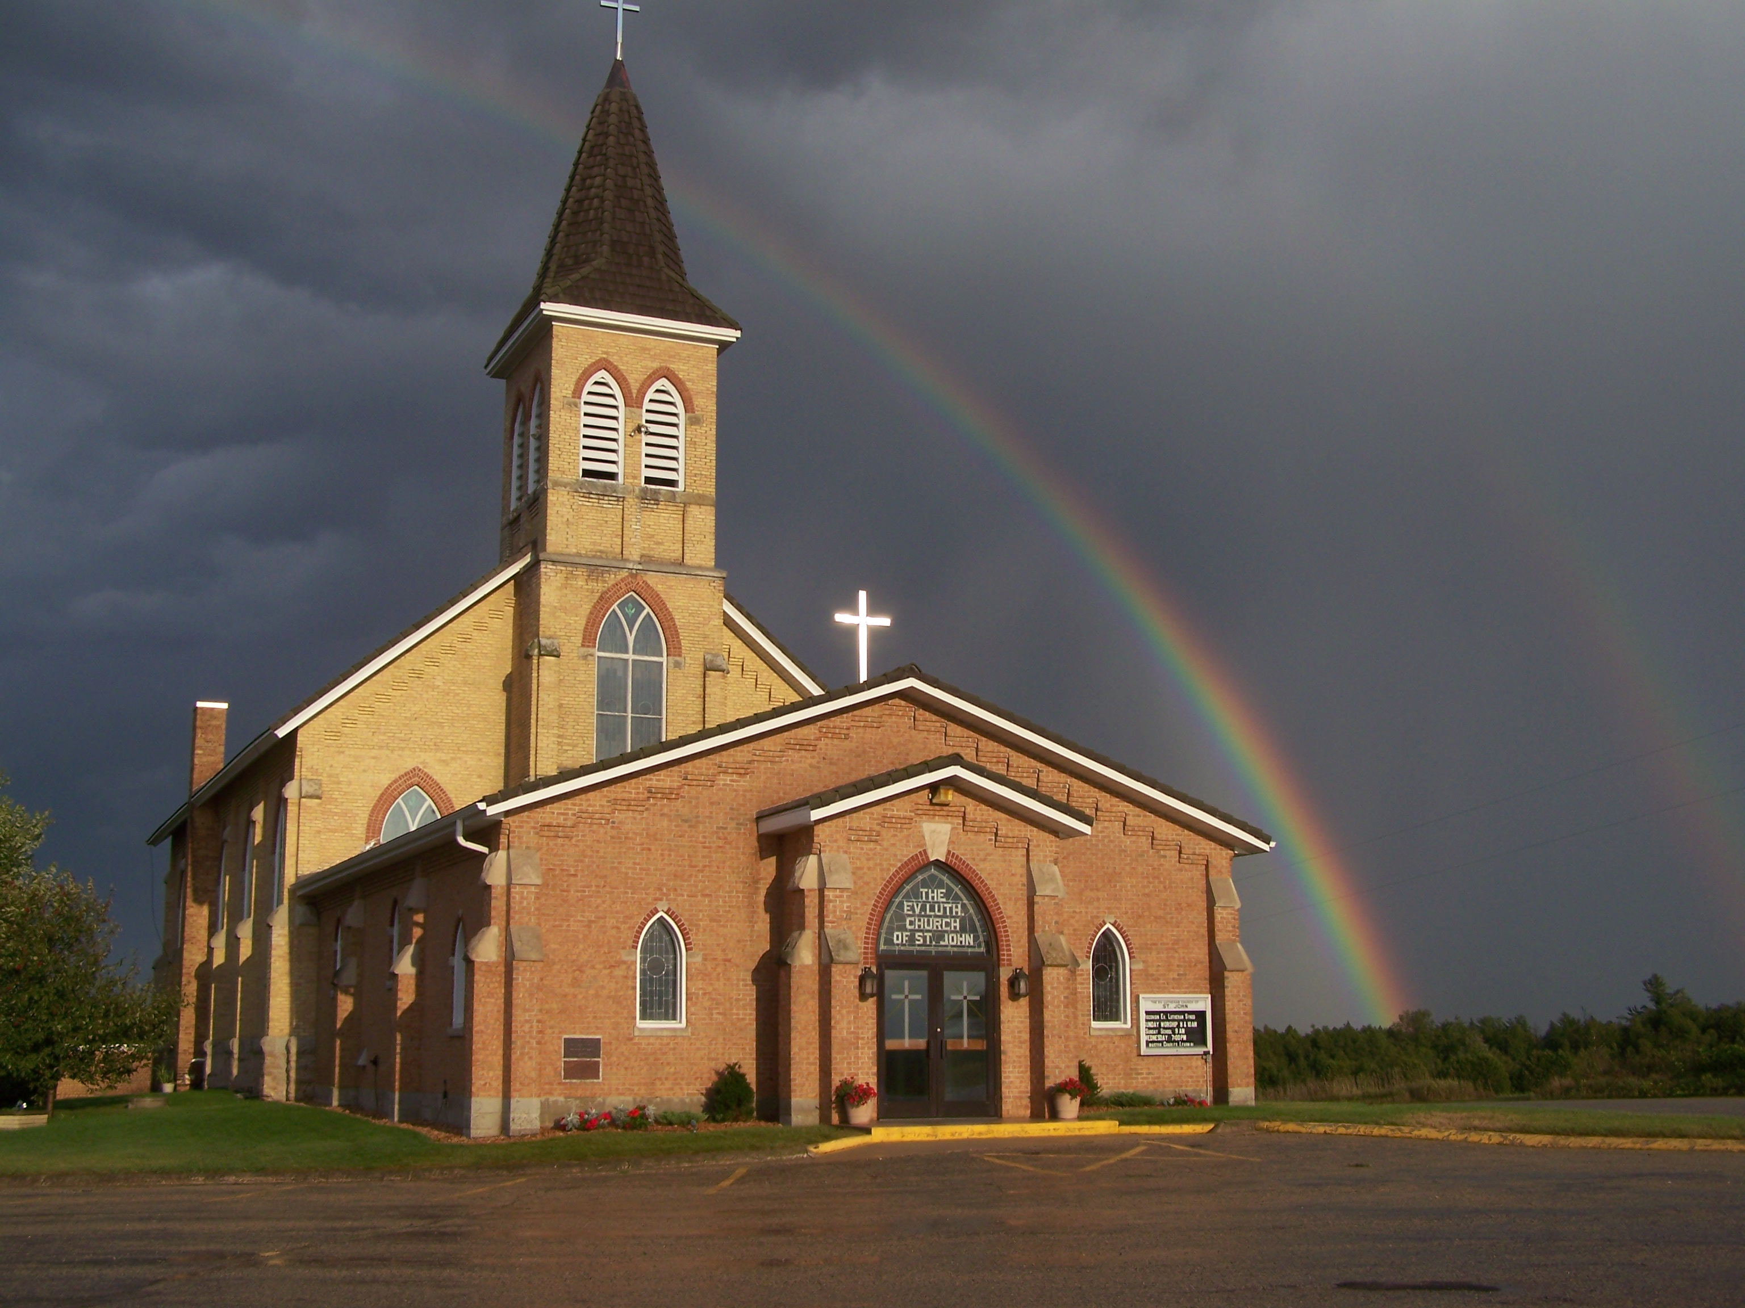
The Evangelical Lutheran Church of St. John
N1916 Church Road
Peshtigo, Wisconsin 54157-9673
Pastor Sargent 920-228-1061

04/22/2020

Dear St. John Lutheran Church Family,
The Celebration of Easter Sunday has come and gone. We celebrated with special music, hymns and the reading of the Resurrection Story, but there was something missing, wasn’t there?
What I missed most was being with fellow believers physically, experiencing Holy Week together as a community. There were many sights and sounds we didn’t encounter this year, the waving of palm branches on Palm Sunday, the taste of the Lord’s Supper on Maundy Thursday; the darkness of Good Friday; the smell of the lilies on Easter Sunday and the sound of shouting together “HE IS RISEN! HE IS RISEN INDEED!”
Those are very physical and real experiences that we missed this year. The physical matters...a hug from a loved one; the sound of children laughing; seeing a beautiful sunrise before service, the taste of bacon at breakfast after church. All these things are important because God created us to experience them. He made us physical beings.
And that is why it felt as if there was something lacking during Holy Week. But in spite of it all, that doesn’t change what really matters - Jesus and His resurrection.
In John 11 Jesus said to Martha, “I am the resurrection and the life. The one who believes in me will live, even though they die; and whoever lives by believing in me will never die. Do you believe this?”

We will have plenty of time to spend together in eternity, but until then rejoice in the victory by Jesus on the cross! Stay focused. Remember the mission of making disciples. Share the story!
Invite your friends and neighbors to worship with us online at 9:30 am each Sunday!
In Christ’s Love,
Pastor Daniel Sargent

News from the Congregation:

- Leo and Cecile Seefeldt celebrated their 70th wedding anniversary on the 22nd of April. We wish them God’s richest blessings.

- Malva Berth was laid to rest at our cemetery on Friday the 24th of April. A private funeral service was held at Berth and Rosenthal.

- The Congregation has paid the $5,000 down payment for the Organ Repairs and improvements. Please see attached letter from Dave Fabry. If, for some reason the congregation is not able to raise the money for the entire organ improvements, they will only charge us for the work we can afford.

- The Congregation received a loan from the Government under the CARES provision. The amount is $56,900. This is meant to cover salaries and benefits for our staff and according to the Government information, it will be a grant, if we do not lay off staff before the end of June. The Council will keep all staff in place till the end of June when Mr. and Mrs. List are scheduled to resign and move to Arizona.

- Arrangements for Confirmation questioning and Confirmation Day are being discussed. The Confirmands will be ready to be confirmed by the 3rd of May but how we will hold the questioning and service is still being discussed.

Services of worship
- All in person worship services will be canceled until further notice. (See website: for continuing updates: stjohnpeshtigo.org)
- We are live streaming services on Facebook. Sunday Services: 9:30 am
http://www.facebook.com/The-Evangelical-Lutheran-Church-of-St-John-Town-of-Grover-WELS-100389558275581/
You can also Go to our YouTube link at:
https://www.youtube.com/channel/UCJ8tkCadzLHuxGWLhovgl8Q
- We are planning to put Sunday School and Bible Study videos on YouTube in the near future. Look on our Website for details.

Spiritual aid
As always, please keep your church family in your prayers. If you have a specific need please call or e-mail church or Pastor.
Regular financial giving
During this time, the work of the church and its financial obligations will not cease. Even though we won’t be passing a plate on Sundays all of your support for this Ministry remains as vital as always. If you have an offering you would like to give, you can take advantage of our online giving program (Information on our Website), or you may mail it to the church or you can stop in at the School Building and place the offering in a lock box, Sundays from 10:30am to 12:00 and Wednesday and Thursday 8:00 am to 12:00.

If you have any questions or concerns, please contact Pastor Sargent. 920-228-1061

